**RAWAT EDUCATIONAL GROUP WEBSITE**

1. Menu:
2. About
3. Rawat Group
4. The Mentors
5. Mr. B.S. Rawat
6. Mr. Hemendra Rawat
7. Mr. Narendra Singh Rawat
8. Our Philosophy
9. Awards and Achievements
10. Why Choose Rawat?
11. Principals
12. Alumni
13. Rawat Schools and Colleges
14. Gallery
15. Memories
16. Events
17. Media
18. Blog
19. Contact
20. 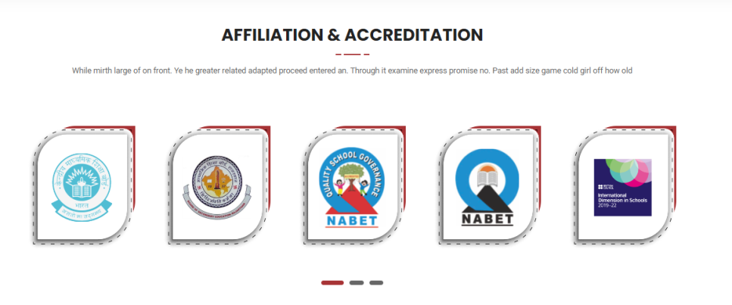

Sub heading: Creating A Culture of Recognition

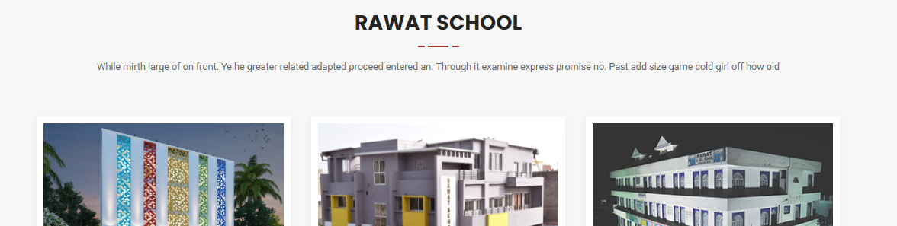

Instead of RAWAT SCHOOL it will come: "Splendid Empire of Rawat Group"

1. 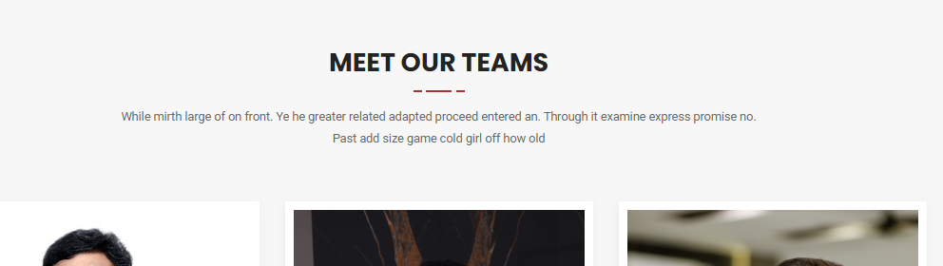

Instead of Meet Our Teams: The Mentors

Sub Heading: A mentor is someone who allows you to see the hope inside yourself

1. 

Heading: Let's have a Glimpse of **Rawat Educational Group**

1. 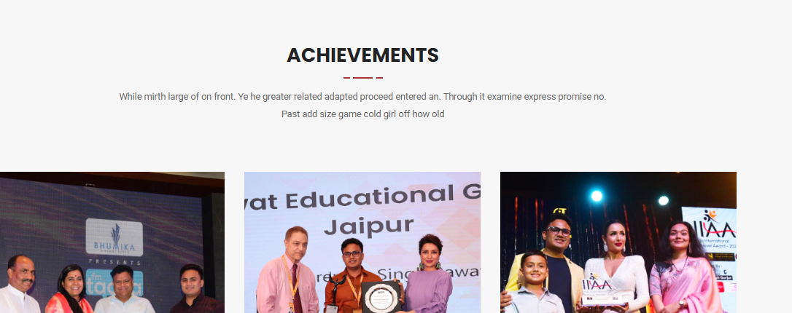

Subheading: Rawat Educational Group has become one of the Leading Educational Institutions of Jaipur under the wonderful guidance of Chairman Mr. B.S. Rawat. The motive of the group is to groom the overall personality of each and every child.